Circuit Analysis (Lab # 2)

Experiment 2: Measurements of Waveforms and Fundamental Quantities, Basic resistive circuits.

Name: Muhammad Zia Ur Rehman Zahid Registration No: 2025-CE-104
Date: 16-March-2026 Grade and Signature: ………………………
CLO3 | Make measurements in their own constructed electric circuits.
Psychomotor/Affective | Level1 (1) | Level2 (2-3) | Level3 (4-5) | Level4 (6-7)
Report Marks (3) |  |  | Total marks (10)

_
Objectives: This experiment will provide exposure to measurements of waveforms and Fundamental Quantities, Basic resistive circuits. A primary purpose of this lab course is for you to master the use of electronic test equipment and measurement of fundamental quantities.

Equipment required:
Power Supply, Breadboard, Oscilloscope, Signal Generator Connecting wires, Resistances, Multimeter.
Procedure

Experiment # 1

SIGNAL GENERATOR AND OSCILLOSCOPE
- Use the signal generator and the oscilloscope to perform the following tasks.
- Build circuit ‘A’ shown below in Figure 1.
- Set the signal generator to generate a sinusoidal signal with a frequency of 100 Hz and peak-to peak voltage of 5V.
- Set up one probe across input signal, and another across R1 and R2 alternatively.
- Measure and draw all the voltages and time related parameters on the graphs below.
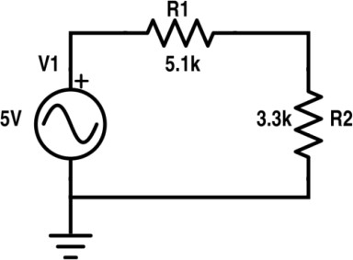
Figure 1 Circuit ‘A’

Resistor | Input voltage | RMS Voltage | P-P Voltage
R1 | 5V | 1.07V | 3.04V
R2 | 5V | 0.69V | 1.96V

Frequency =100hz, Timeperiod =10ms
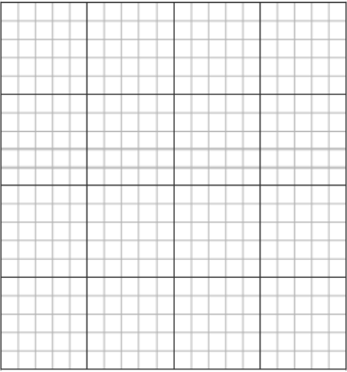

SCALE: horizontal box = 1ms, vertical box = 0.5v
5V
0
-2.5V
-5V
20ms
15ms
10ms
5ms
5V
2.5V
2.5V
20ms
-5V
-2.5V
0
15ms
10ms
5ms
Figure 2 Input Voltage Signal Figure 3 Voltage Signal across R1



0
-2.5V
-5V
20ms
15ms
10ms
5ms
5V
2.5V
2.5V
5V
5ms
10ms
15ms
20ms
-5V
-2.5V
0

Figure 5 Voltage Signal across R2 Figure 6 Draw 7V Sinusoidal

Experiment # 2

SIGNAL GENERATOR AND OSCILLOSCOPE
- Use the signal generator and the oscilloscope to perform the following tasks.
- Build circuit ‘B’ shown below in Figure 7.
- Set the signal generator to generate a sinusoidal signal with a frequency of 200 Hz and peak-to peak voltage of 7V.
- Set up one probe across input signal, and another across R1, R2 and R3 alternatively.
- Measure and draw all the voltages and time related parameters on the graphs below.
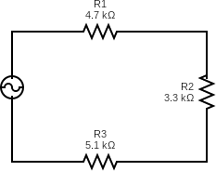
Figure 7 Circuit ‘B’

Resistor | Input voltage | RMS Voltage | P-P Voltage
R1 | 7V | 0.89V | 2.51V
R2 | 7V | 0.62V | 1.76V
R3 | 7V | 0.96V | 2.72V
R1 and R2 | 7V | 1.51V | 4.27V
R2 and R3 | 7V | 1.59V | 4.49V

Frequency =200hz , Timeperiod =5ms
Scale: horizontal box = 1ms , Vertical box = 0.5v



2.5V
5V
5ms
10ms
15ms
20ms
-5V
-2.5V
0
0
-2.5V
-5V
20ms
15ms
10ms
5ms
5V
2.5V

Figure 8 Input Voltage Signal Figure 9 Voltage Signal across R1

2.5V
5V
-5V
-2.5V
0
-2.5V
-5V
20ms
15ms
10ms
5ms
5V
2.5V

20ms
5ms
10ms
15ms
0

Figure 10 Voltage Signal across R2 Figure 11 Voltage Signal across R3



5V
2.5V
0
-5V
0
2.5V
5V
-2.5V
5ms
10ms
20ms
15ms
20ms
10ms
15ms
-5V
-2.5V
5ms

Figure 12 Voltage Signal across R1 and R2 Figure 13 Voltage Signal across R2 and R3

Post Lab Questions
- Define Ohm’s law.
Ohm’s Law states that the current flowing through a conductor is directly proportional to the voltage across it, provided temperature remains constant.
V=IR

- What is resistor?
A resistor is a passive electronic component that limits or opposes the flow of electric current in a circuit.
It is used to control voltage and current.

- How resistor works?
A resistor works by resisting the flow of electrons in a circuit.
When current passes through a resistor, some electrical energy is converted into heat, which reduces the current.

- What is your inference from the input and output waveforms on oscilloscope?
From the oscilloscope waveforms we observe that:
- The input signal is a sinusoidal wave.
- The output signals across resistors are also sinusoidal.
- The frequency and phase remain the same.
- Only the amplitude (voltage magnitude) decreases due to voltage division in series resistors.

- Show calculations of 7V input signal (Figure 10) from signal generator.
  - Voltage calculations (Following volt/div and number of boxes of oscilloscope)
  - Frequency/Period calculations (Following Steps in frequency measurements section)
  - Current calculation (Ohm Law)
Input signal:
- Vpp=7V
Peak voltage:
Vp=Vpp/2=3.5V
RMS voltage:
Vrms=Vpp/(2√2)V≈2.47

a) Voltage Calculation (Oscilloscope)
Example:
If
Volt/div = 1V
Number of vertical divisions = 7
Vpp= (Volt/div) ×No. of divisions
Vpp=1×7=7V

b) Frequency / Period Calculation
Signal generator frequency:
f=200Hz
Period formula:
T=1/f
=1/200
T=0.005s=5ms

c) Current Calculation (Ohm’s Law)
Total resistance:
R1 = 4.7kΩ
R2 = 3.3kΩ
R3 = 5.1kΩ
RT=4.7kΩ+3.3kΩ+5.1kΩ=13.1kΩ
Using Ohm’s law:
I=V/R
=2.47/13.1k ≈0.000188A ≈0.188mA
Final Current ≈ 0.188 mA

